**PROJECT**

Database Systems (DB)

**Spring – 2020**

Submitted To

Mam Saliha Zahoor

Submitted By

**Zain Asghar (19011519-062)**

**Muhammad Bilal (19011519-115)**

**Sabir Hussain (19011519-129)**

**Section B**



**Department of Computer Science**

**Faculty of Computing and Information Technology**

**University of Gujrat, Hafiz Hayat Campus**

**Project Description**

**Transport System** is facing problem in keeping the record of their customers manually. They have to look in thousands of records on the register to get a single customer.

They are also having issues in keeping all the records consistent as they have to waste a lot of time in single transaction.

They need an online system to get rid of this problem. All the customers and employees will be stored in a database and the employees will be able to perform different tasks on the data like searching, adding, updating and delete accounts of customers.

**PROBLEM SPECIFICATION**

Transport Systems that were suggested till now, are not up to the desired level. There is no single system which automates all the process.

In order to build the system, all the processes in the business should be studied; System study helps us under the problem and needs of the application. System study aims at establishing requests for the system to be acquired, development and installed. It involves studying and analyzing the ways of an organization currently processing the data to produce information. Analyzing the problem thoroughly forms the vital part of the system study. In system analysis, prevailing situation of problem is carefully examined by breaking them into sub problems. Problematic areas are identified and information is collected. Data gathering is essential to any analysis of requests. It is necessary that this analysis familiarizes the designer with objectives, activities and the function of the organization in which the system is to be implemented.

**Existing system**

✓Existing system is totally on book and thus a great amount of manual work has to be done. The amount of manual work increases exponentially with increase in services.

✓Needs a lot of working staff and extra attention on all the records.

✓In existing system, there are various problems like keeping records of items, seats available, prices of per/seat and fixing bill generation on each bill.

✓Finding out details regarding any information is very difficult, as the user has to go through all the books manually.

✓Major problem was lack of security.

**Proposed system**

The system is very simple in design and to implement. The system requires very low system resources and the system will work in almost all configurations. It has got following features:

✓Needs a lot of working staff and extra attention on all the records.

✓Ensure data accuracy.

✓Records are efficiently maintained by DBMS.

✓DBMS also provides security for the information.

✓Any person across the world, having internet can access this service.

✓Availability of seats can be enquired very easily.

✓Passengers can also cancel their tickets easily.

✓Minimum time needed for the various processing

✓Better Service

✓Minimum time required

✓This would help the corporation prepare and organize its schedules more efficiently on the basis of traffic demand.

**SOFTWARE REQUIREMENT SPECIFICATION**

**Hardware Requirements:**

PC with Pentium IV processor.

512 MB RAM or above.

40 GB Hard Disk or above.

**Software Requirements:**

Operating system : Windows XP (or latest).

Back end : SQL Server 2012

**Case Study**

Consider the following set of requirements for a Transport database that is used to keep track of Customers.Transport is a network of more than one Routes. Each route has a unique name. Each route has a **route _code, route _address route _phones.** Each route has multiple employee. Route is managed by an employee that is Route manager. An employee is referred to only one route having **E_name,E_address,E_type,E_id,E_phone**.When Customer visits the route Having their **C_name, C_CNIC, C_phones**, and **coustomer_serial_number**.Accounts have **Acc_number, Acc_Type** (e.g. saving, checking) **and Acc_balance**. Other Route might use the same designation for accounts. So to name an account uniquely, we need to give both the route number to which this account belongs to and the account number.Not all bank customers must own accounts and a customer may have at most 5 accounts in the Route.An account must have only one customer.A customer may have many accounts in different route. Transport Allow seates having, **seat_amount, seat_type**. Which is related to customer having C_address and each and every seat must be connected with one route whereas a branch has multiple routes.

**E-R-D Diagram**

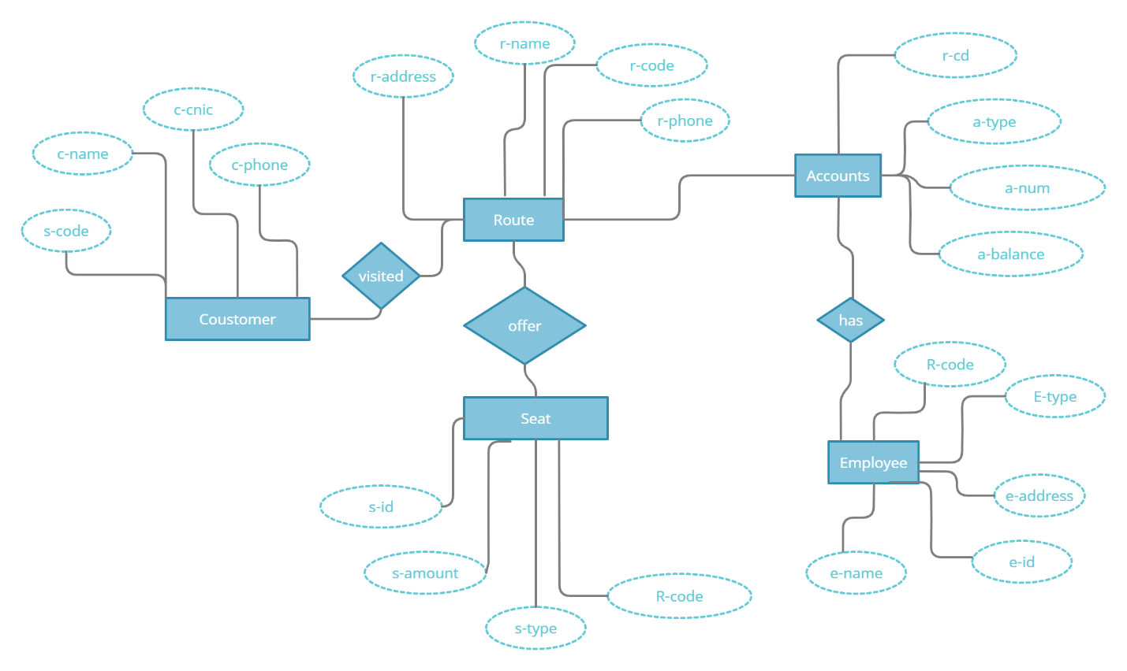

**Normalizations**

**First Normal Form (1NF): -**

|  |  |  |  |  |  |  |  |  |
| --- | --- | --- | --- | --- | --- | --- | --- | --- |
| **R_code** | **R_Name** | **R_Address** | **R_phone** | **S_sc** | **C_name** | **C_cnic** | **C_phone** | **A_type** |
| 101 | Gujranwala | Gujrat Main Ada B-22 | 03022334458 | 112 | Ali | 34403-7768066-5 | 0309998877 | Driver |
| 102 | Peshawar | Niazi Express B-92 | 03098877766 | 221 | Adeel | 34403-7768066-6 | 0377887766 | Conductor |
| 103 | Sialkot | Sialkot Lari Ada B-101 | 03099887776 | 222 | Atim | 34403-7768066-7 | 0333222776 | Receiptionist |

|  |  |  |  |  |  |  |  |  |  |
| --- | --- | --- | --- | --- | --- | --- | --- | --- | --- |
| **A_balance** | **A_num** | **S_id** | **S_type** | **S_amount** | **E_Name** | **E_Id** | **E_phone** | **E_address** | **E_type** |
| 2400 | 012345678 | 001 | Gold | 10000 | Ahmad | 111 | 32214625 | Gujrat | Driver |
| 3200 | 012345674 | 002 | Standard | 20000 | Haider | 222 | 54221313 | Lahore | Conductor |
| 3200 | 012345673 | 003 | Diamond | 30000 | Usman | 333 | 56315646 | Islamabad | Receiptionist |

**Second Normal Form (2NF): -**

|  |  |  |  |
| --- | --- | --- | --- |
| **R_Code** | **R_Name** | **R_Address** | **R_Phone** |
| 101 | Gujranwala | Gujrat Main Ada B-22 | 03022334458 |
| 102 | Peshawar | Niazi Express B-92 | 03098877766 |
| 103 | Sialkot | Sialkot Lari Ada B-101 | 03099887776 |

**Route Table:**

**Employee Table:**

|  |  |  |  |  |  |
| --- | --- | --- | --- | --- | --- |
| **E_Id** | **E_Name** | **E_phone** | **E_Address** | **E_Type** | **R_Code** |
| 111 | Ahmad | 32214625 | Gujrat | Driver | 101 |
| 222 | Haider | 54221313 | Lahore | Conductor | 102 |
| 333 | Usman | 56315646 | Islamabad | Receiptionist | 103 |

**Customer Table:**

|  |  |  |  |
| --- | --- | --- | --- |
| **S­_SC** | **C_Name** | **C_CNIC** | **C_Phone** |
| 112 | Ali | 34403-7768066-5 | 10099988877 |
| 221 | Adeel | 34403-7768066-6 | 8777887766 |
| 222 | Faizan | 34403-7768066-7 | 33334444776 |

**Account Table:**

|  |  |  |  |  |
| --- | --- | --- | --- | --- |
| **Acc_Num** | **Acc_Type** | **Acc_Balance** | **S_SC** | **R_code** |
| 12345678 | Driver | 2400 | 112 | 101 |
| 12345674 | Conductor | 3200 | 221 | 102 |
| 12345673 | Receiptionist | 3200 | 222 | 103 |

**Seat Table:**

|  |  |  |  |  |
| --- | --- | --- | --- | --- |
| **S_id** | **S_amount** | **S_type** | **R_code** | **Acc_Num** |
| 001 | 10000 | Gold | 132 | 12345678 |
| 002 | 20000 | Standard | 321 | 12345674 |
| 003 | 30000 | Diamond | 432 | 12345673 |

**Note:**

Our tables are now fully normalized because there is no transitive dependency in them.

**Code**

**Route Table:**

create table Route

(

R_code int constraint pk1 primary key,

R_name varchar(20),

R_address varchar(50),

R_phone bigint constraint uk1 unique

);

insert into Route values (101,'Gujrat', 'Gujrat Main Ada B-22', 03007124422);

insert into Route values (102,'Peshawar', 'Niazi Express B-92', 03001214455);

insert into Route values (103,'Sialkot', 'Sialkot Lari Ada B-101', 03002456321);

select *from Route

drop table Route

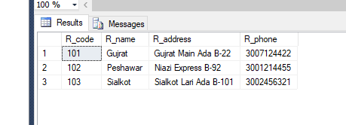

**Employee Table:**

create table Employe

(

E_id int constraint pk2 primary key,

E_name varchar(20),

E_address varchar(30),

E_type varchar(20),

E_phone bigint constraint uk2 unique,

r_code int ,

constraint fk1 foreign key (r_code) references Route(R_code),

);

insert into Employe values (01,'Ahmad','Gujrat','Cashier',030445511,101);

insert into Employe values (02,'Haider','Peshawar ','Receiptionist',030021455,102);

insert into Employe values (03,'Usman','Sialkot','Driver',0300025412,103);

select *from Employe

drop table Employe

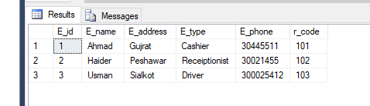

**Customer Table:**

create table customer

(

c_ssc int constraint pk3 primary key,

c_name varchar(20),

c_cnic varchar(20)constraint uk3 unique,

c_phoneno bigint constraint uk4 unique,

);

insert into Customer values (0231,'Ali','34403-77068069-5',1009998877);

insert into Customer values (4986,'Adeel','34403-77068069-6',8777887766);

insert into Customer values (3215,'Atim','34403-77068069-7',3333222776);

select *from customer

drop table customer

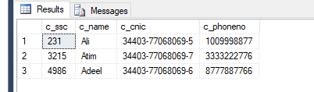

**Account Table:**

create table account

(

a_num int constraint pk4 primary key,

a_type varchar(20),

a_balence bigint,

C_ssc int,

r_code int,

constraint fk3 foreign key(C_ssc) references customer(c_ssc),

constraint fk4 foreign key (r_code) references Route(R_code),

);

insert into account values (12345678,'driver',24000,0231,103);

insert into account values (12345674,'conductor',32000,4986,102);

insert into account values (12345673,'receiptionist',45980,3215,101);

select *from account

drop table account

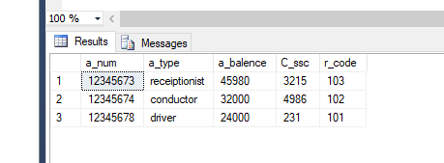

**Seat Table:**

create table seat

(

s_id int constraint pk5 primary key,

s_type varchar(20),

s_amount int,

r_code int,

a_num int,

constraint fk5 foreign key (r_code) references route(r_code),

constraint fk6 foreign key (a_num) references account(a_num),

);

insert into seat values (001,'Gold',100,123,12345678);

insert into seat values (002,'Standard',200,153,12345674);

insert into seat values (003,'Diamond',300,432,12345673);

select *from seat

drop table seat

